[Course Prefix & No. (e.g., EDUC-321)]

[Course Title (as it appears in the catalog)]
[Term (e.g., Spring 2018)]
[Course credit hours (e.g., 3.0 credits)]

Instructor Information
[Instructor Name]
[Contact Information (Phone, E-mail, Website)]
[Office Hours and Access Information]

Student Learning Information

Course Description
[A description of the course consistent with what appears in the university catalog]

Prerequisites
[List any courses students must take before this one, or just say “None”.]

Course Purpose within a Program of Study
[The purpose of the course, expanding on the course description and/or informing the students what role the course plays in the degree program]

Statement of Expected Learning
By the end of this course, you will able to:
- [List learning goals (e.g., outcomes, objectives, competencies, performance criteria)
(n.b., in most cases, there will be between 3 and 8 statements of expected learning). For guidance from the Provost, see Developing Course Level Outcomes.]

Course Materials

Required and Recommended Texts, Readings, and Resources
[Required and recommended readings, texts, and resources that will support student performance in the course]

Required and Supplemental Materials and Technologies
[Additional materials and technologies that students will need for the course]
See Drexel’s Recommended Specifications for Computers and Software. Consider investing in an inexpensive headset for listening to audio without disturbing others and for clearly contributing your voice to online collaborations.

Assignments and Assessments

Graded Assignments and Learning Activities
[Assignments/Activities for which students will be graded. For guidance from the Provost, see Assessments.]
[Provide specific and descriptive criteria for the evaluation of learners’ work, tied to the course grading policy. Such criteria can be organized into a rubric. For convenience, a sample rubric is offered below if you wish to use one.]

Submission Information
[How students should submit assignments (e.g., upload files to Blackboard Learn Assignments)]

Grading Matrix
[Detail of how a score/grade for each assignment and/or activity is used to calculate the final score/grade for the course (such as the sample below)]
Assignments | Weight (%)
3 Exams (15% each) | 45
Project I | 15
Project II | 20
Discussion Board Participation – 10 posts (2% each) | 20
Grade Scale
[Point breakdown for each possible grade (such as below)]
Grade | Points Earned
A+ | 98-100
A | 93-97
A- | 90-92
B+ | 88-89
B | 84-87
B- | 82-83
C+ | 79-81
C | 77-78
C- | 74-76
D+ | 71-73
D | 69-70
D- | 66-68
F | <66

Course Calendar
[A calendar of course activities, readings, assignments, and/or exams (such as below). The level of detail will be determined by the faculty member or department in which the course is taught.]
Week | Learning Activities | Assessments
1
2
3
4
5
6
7
8
9
10

Academic Policies
Academic Integrity: See Code of Conduct, which can also be found in the Student Handbook.
Students with Disabilities: Request Accommodations
Course Add/Drop: Provost Add/Drop Policy
Course Withdrawal: Provost Course Withdrawal Policy

Course Change Policy: Faculty members reserve the right to make discretionary changes to the course during the term. All significant changes will be provided to students in writing.

Sample Rubric
Assessment Task: Each student will make a 5-minute presentation on the changes in one community over the past 30 years. The student may focus the presentation in any way he or she wishes, but there needs to be a thesis of some sort, not just a chronological exposition. The presentation should include appropriate photographs, maps, graphs, and other visual aids for the audience.
 | Excellent | Competent | Needs work
Knowledge/  understanding  (20%) | The presentation demonstrates a depth of historical understanding by using relevant and accurate detail. Research is thorough and goes beyond what was presented in class or in the assigned texts. | The presentation uses knowledge that is generally accurate with only minor inaccuracies and that is generally relevant to the student's thesis. Research is adequate but does not go much beyond what was presented in class or in the assigned text. | The presentation uses little relevant or accurate information, not even that which was presented in class or in the assigned texts. Little or no research is apparent.
Thinking/inquiry  (30%) | The presentation is centered around a thesis, which shows a highly developed awareness of historiographic or social issues and a high level of conceptual ability. | The presentation shows an analytical structure and a central thesis, but the analysis is not always fully developed or linked to the thesis. | The presentation shows no analytical structure and no central thesis.
Communication  (20%) | The presentation is imaginative and effective in conveying ideas to the audience. The presenter responds effectively to audience reactions and questions. | Presentation techniques used are effective in conveying main ideas, but they are a bit unimaginative. Some questions from the audience remain unanswered. | The presentation fails to capture the interest of the audience and/or is confusing in what is to be communicated.
Use of  visual aids  (20%) | The presentation includes appropriate and easily understood visual aids which the presenter refers to and explains at appropriate moments in the presentation. | The presentation includes appropriate visual aids, but these are too few, are in a format that makes the difficult to use or understand, or the presenter does not refer to or explain them in the presentation. | The presentation includes no visual aids or includes visual aids that are inappropriate or too small or messy to be understood. The presenter makes no mention of them in the presentation.
Presentation skills  (10%) | The presenter speaks clearly and loudly enough to be heard, using eye contact, a lively tone, gestures, and body language to engage the audience. | The presenter speaks clearly and loudly enough to be heard but tends to drone or fails to use eye contact, gestures, and body language consistently or effectively at times. | The presenter cannot be heard or speaks so unclearly that she or he cannot be understood. There is no attempt to engage the audience through eye contact, gestures, or body language.

Adapted from Drexel Provost Rubric Development.

Notes to faculty about this syllabus template:
This syllabus template has been created using features aimed at making the document universally accessible, including to students who use screen readers. Features include uses of heading styles, “alt text” for images, data tables with header row, meaningful description of hyperlinks, bulleted (rather than numbered) lists, straightforward language, and easily readable font.
This document is written in Helvetica, a san-serif font (font without extending features called "serifs" at the end of strokes – see image below), which are considered easier to read online. Other readable fonts are Verdana, Tahoma, Trebuchet MS, and Calibri.
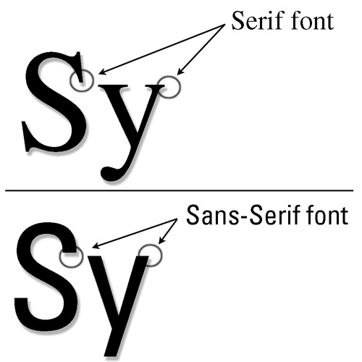

Please keep writing voice consistent. (e.g., Use “you” instead of “student” throughout entire document. This writing voice is also more personal for the student.)
Drexel Inspire provides guidance to help make your course accessible.

